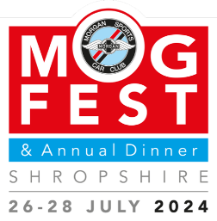Mogfest Gymkhana Entry Form

The Morgan Sports Car Club will be organising a gymkhana as part of Mogfest 24, at Weston Park on 27th July.

The event will take place on a tarmac road so your car shouldn’t get muddy if it’s wet. There will be several fun and slightly tricky tasks for you to complete along the length of the road, which will entertain both the driver and the passenger. It will not be timed – points will be awarded for tasks completed successfully, and deducted for hitting cones or driving on the grass verge.

At the start you will be given a sheet of instructions, showing what to do on each task and the points awarded.

You may enter on the day, but if possible please send in this entry form in advance, so we have an idea of numbers.

Cars may be double-entered but each person can only drive once.

It should not take up too much of your day, so you can enjoy the rest of the day’s attractions. You will be able to take part in other events such as the concours (do the gymkhana afterwards) or the Fun & Games in addition to the Gymkhana.

We will start the event at around 11am and run until around 2.30pm. If you would like to do the gymkhana at a particular time, eg first thing, or after the concours, please let us know below.

**Entry to the Gymkhana is free but you do need to have event tickets to enter the Mogfest site.** Full details can be found at <https://www.morgansportscarclub.com/events/mogfest24> To book day tickets only, phone Scenic Car Tours, who run the MSCC Travel Club, on 01732 879153.

|  |
| --- |
| Name & Membership number: |
| Mobile Phone: |
| Email: |
| Morgan model & year: |
| Registration: |
| Preferred start time: *morning* or *afternoon* (delete as appropriate, or specify) |

**Please return this form to Charles Neal** [**mscc.editor@morgansportscarclub.com**](mailto:mscc.editor@morgansportscarclub.com)