Fun and Games

**Team Registration Form**

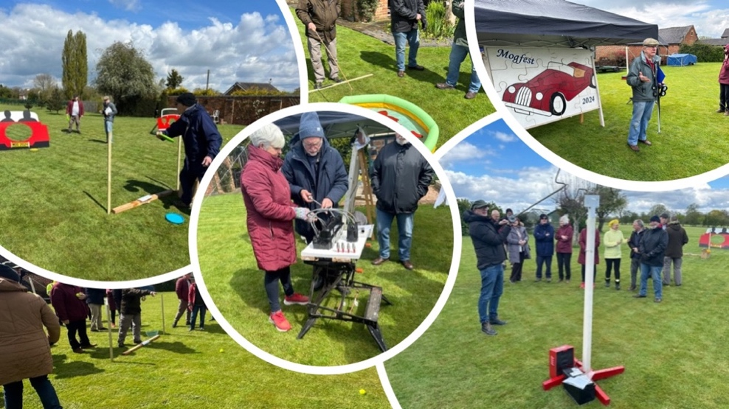

Please provide the following details in order to register your 4-person team for the Fun n Games at Mogfest 2024.

|  |  |  |
| --- | --- | --- |
| **Team Details** | | |
| **Team Name** |  | |
| **Team Leader** | Name: | |
| MSCC Number | Phone Number |
| **Player 2** | Name: | |
| **Player 3** | Name: | |
| **Player 4** | Name: | |

Please note that for insurance purposes, only members of the MSCC may participate in the Fun n Games.

By signing this form, the team leader, on behalf of their team acknowledges that there are risks involved in taking part in these games. A copy of a Risk Assessment is available on request.

Team Leader Signature: _________________

Date

**Please email your completed form to** [Staffordshire.sec@morgansportscarclub.com](mailto:Staffordshire.sec@morgansportscarclub.com)