Fun and Games

**Individual Registration Form**

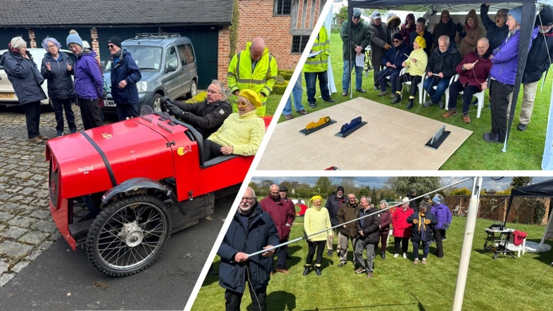

Please provide the following details in order to register for the Fun n Games at Mogfest 24.

|  |  |
| --- | --- |
| **Name** |  |
| **MSCC Number** |  |
| **Mobile Number** |  |

I’d like to register for the following games (tick the box):

|  |  |
| --- | --- |
| Auto Duo Pedal Car |  |
| Model Morgan Racing |  |
| Mog-in-a-bag mystery game |  |
| Mog agility test |  |

Please note that for insurance purposes, only members of the MSCC may participate in the Fun n Games.

By signing this form, you team acknowledges that there are risks involved in taking part in these games. A copy of a Risk Assessment is available on request.

Signature: _________________

Date

**Please email your completed form to** [Staffordshire.sec@morgansportscarclub.com](mailto:Staffordshire.sec@morgansportscarclub.com)